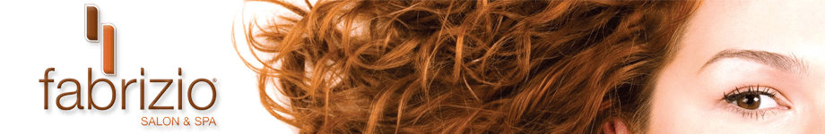

A gift for you!

Fabrizio Salon & Spa
1604 West Sixteenth Street ~ Wilmington, DE 19806
302-656-8660

